

Department | FED
Subject | DSA-2
Academic Year | Ⅰ-Ⅲ Semester(2025-26)
Faculty Name | Ms. Alluri Swathi
Student Name | Boddapati Himavanth Sai Ganesh
Roll Number | 2520030429
Branch | CSE
Course Outcome | 3

Case Study Topic: EduGraph Learning Network Analysis using BFS, DFS, Prim’s & Kruskal’s Algorithms
Work Done Summary:
The application of graph traversal and Minimum Spanning Tree algorithms in analyzing educational learning networks efficiently. An EduGraph Learning Network System was developed where courses and prerequisite relationships are represented using weighted graphs to optimize learning paths and course connectivity.
Implementation Details:
- Created graph structure using adjacency matrix for representing course connections.
- bfsTraversal() method performs Breadth First Search to explore courses level-by-level.
- dfsTraversal() method performs Depth First Search to analyze complete prerequisite chains.
- addEdge() method connects courses with weighted relationships representing learning difficulty.
- primMST() method constructs Minimum Spanning Tree using Prim’s Algorithm for optimized learning paths.
- kruskalMST() method generates Minimum Spanning Tree using Kruskal’s Algorithm for efficient network connectivity.
- findParent() and unionSets() methods implemented Disjoint Set operations for cycle detection in Kruskal’s Algorithm.
- displayGraph() module prints all course connections and weights.
- compareAlgorithms() analyzes traversal and MST algorithm performance.
- Main method demonstrated BFS traversal, DFS traversal, Prim’s MST generation, Kruskal’s MST generation, and graph analysis.

Result: Screenshots/Output
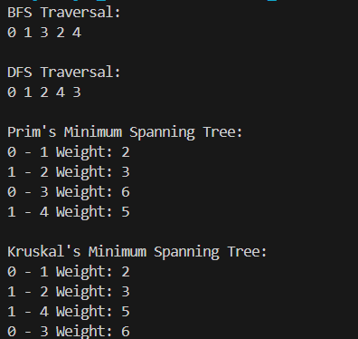

- Successfully represented course prerequisite network using graphs.
- BFS traversal explored courses level-by-level.
- DFS traversal analyzed complete dependency paths.
- Prim’s and Kruskal’s algorithms generated optimized learning connectivity paths.
- Efficient graph traversal and network optimization observed.

Time Complexity Analysis
• BFS Traversal: O(V + E)
• DFS Traversal: O(V + E)
• Prim’s Algorithm: O(V²) using adjacency matrix
• Kruskal’s Algorithm: O(E log E)
• Compared to manual network analysis, graph algorithms provide efficient connectivity analysis and optimized learning path generation.

GitHub Link: https://github.com/himavanthsaiganesh/DSA2-CASE-STUDY-CO---3

Student Signature | Faculty Signature

